Inorganic Photochemistry
Chemistry 7350 Prof. Claudia Turro
Autumn 2021 – August 24 – October 11 4109 Newman-Wolfrom Laboratory
Tu/Th 9:35 – 10:55 AM, 162 McQuigg Lab turro.1@osu.edu

Text: Reference textbook, although not required: Nicholas J. Turro, V. Ramamurhty, J. C. Scaiano “Principles of Molecular Photochemistry, An Introduction”, University Science Books, 2009.
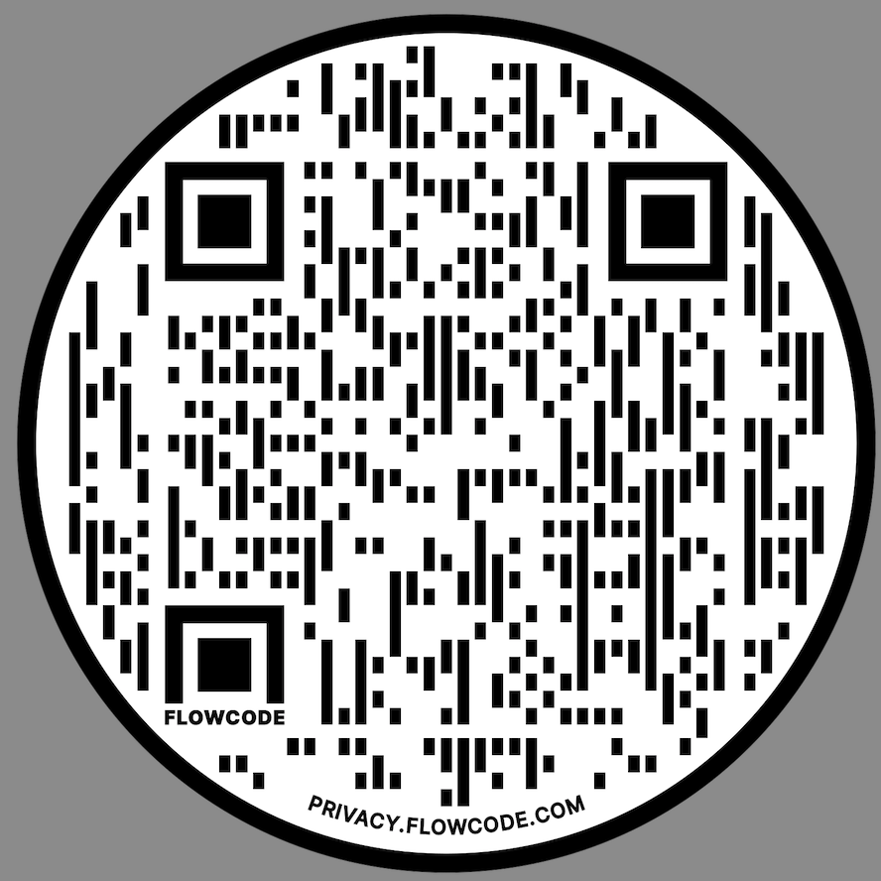
Handouts: References and photocopies of book chapters and articles on subjects to be covered in class will be provided and posted on the course website.
Website: https://research.cbc.osu.edu/turro.1/graduate-courses-2/chem-7350-inorganic-photochemistry/
Other Classic References (plus others on website):
• Roundhill, D. M. Photochemistry and Photophysics of Metal Complexes; Plenum: New York, 1994.
• Adamson, A. W.; Fleischauer, P. D., Eds. Concepts of Inorganic Photochemistry; John Wiley: New York, 1975.
• Journal of Chemical Education 1983, 60, 785–887.
Course Format: The goal of the course will be to acquaint the students with the basic concepts and current topics in the photochemistry and photophysical properties of inorganic compounds.
In order for students to be able to understand the literature, background material will be covered during the first part of the course.
Once there is an understanding of the basic concepts, I will spend several lectures on the presentation of classical aspects of inorganic photochemistry and excited state processes, as well as measurement techniques and relevant kinetics. The following topics may also be included, although specific subjects will vary depending on presentation topics chosen by the students.
Excited states, electron, energy, and proton transfer
Photoaquation and ligand-exchange photochemistry
Spectroscopy; Time-resolved and steady-state measurements; Photoredox catalysis; Photocatalysis
Biological systems; Sensors; Materials; Solar energy conversion
Presentation and Term Paper: The last few lecture periods of the term will be spent on the presentation by students of specific current issues on inorganic photochemistry. These presentations will be approximately 25 min each with 5 min of discussion on a topic chosen from the current literature based on recent articles. I will choose articles and distribute one to each student. This paper will be the basis of the student's term paper and presentation. Each student in the class will provide written comments on each presentation. All students are required to read the papers prior to the presentation date.
Course Grade: The overall grade of the course will be based on the presentation and a 8 - 10 page (double spaced) paper on the same subject as the oral presentation. A pdf file of the first draft or detailed outline of the written paper must be emailed to me on September 14 (use your last name for the file name). I will provide comments on the paper on points that must be changed or included in the presentations and the final version of the paper by September 20. The final version of the paper will be due on the last class, October 11. Details on the topic guidelines and paper format will be provided on a separate handout.
There will be no midterm or final exams. Absences from class and lack of participation may influence the final grade in the course.
Screenshot of Course Website

