Lab-18 User Guide
PI: Benjamin Conner Physics building 1140

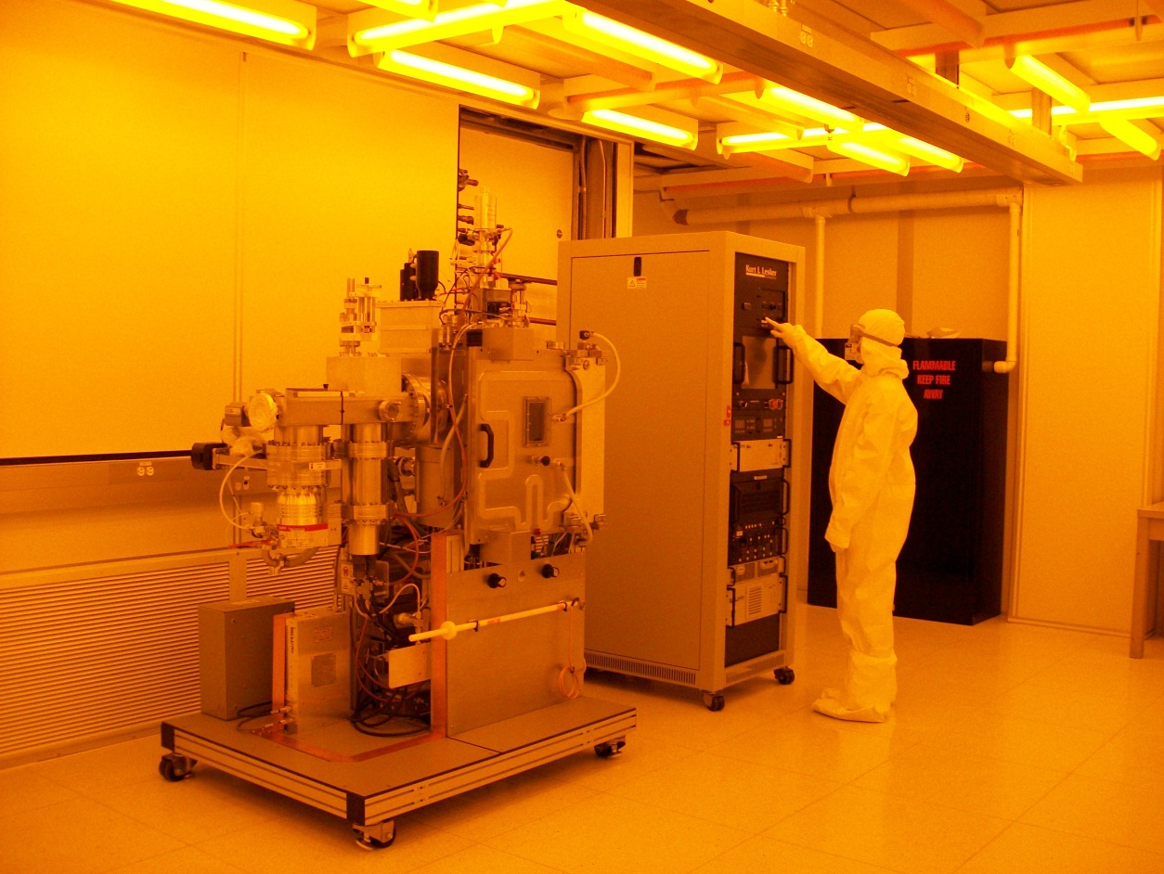

Lab-18 Loading 1
- Sign in to the log sheet and record the base pressure of the machine in the log book (8.40x10⁻⁸ in the picture below).
- This is the Vacuum page. Other pages can be accessed via tabs at the top (Deposition, Gas, Heating, Cooling, and Platen motion).
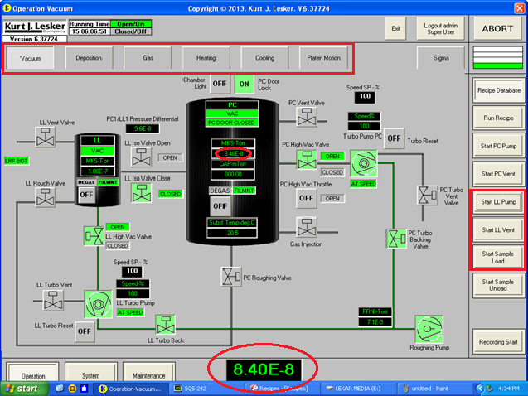
recipes
Only use these buttons!
- Mount your samples on one of the 6” metal holders. Samples must be less than 2mm thick (the height pf the pin on the fork).
- On the right side of the machine press Start LL (Load Lock) Vent. This will bring the load lock up to atmospheric pressure.
- Load the sample disc with the samples facing down. You should be able to see all 3 pins.
- Close the load lock door and press Start LL Pump. When the recipe is complete press the ok button.
- To load the sample into the main chamber, press Start Sample Load.
- For most coating operations the sample is rotated to insure uniform coverage.
Notes:
- PC stands for Primary Chamber.
- On the sample holder, only Kapton tape is allowed.

Lab-18 Loading 2
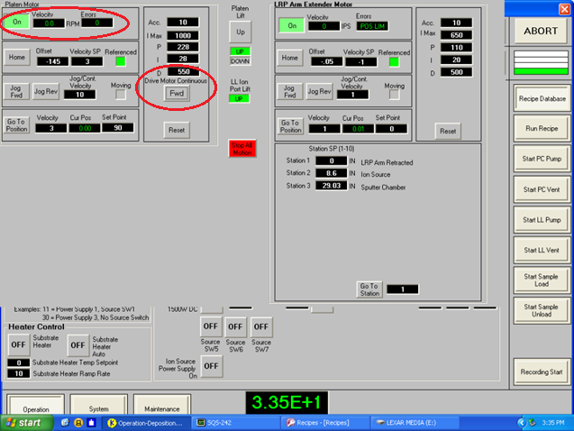

If not green, find Ben.
- Go to the Platen Motion page and press the Fwd button. The rotation speed is displayed in the upper left-hand corner.
  - If it’s already green push it twice. At the top right Velocity should be 10 RPM and the Errors box should say MOVING.
Notes:
- Never change these parameters.
- When loading the holder, use fingers to stabilize the holder.
- E-beam holder is loaded by Ben every week. Here shows the holder and shutter.

Lab-18 Thickness monitor 1
- Go to the SQS-242 program.
- From the upper left select Edit then Film.
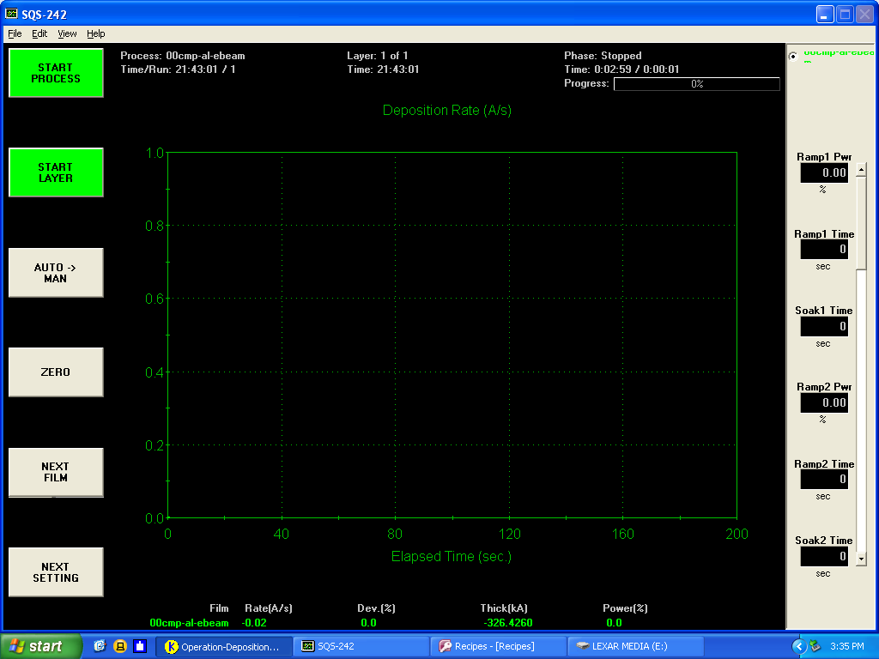
- Click new and name your film with your initials, material, and gun1, 2, 3 or eb for e-beam (ex. BW-Al-eb or BW_Al_g2).
- Select your material from the list and input the correct value into Sensor Tooling 1. The Sensor Tooling 1 value for e-beam/gun 1, 2, and 3 can be found in the front cover of the log book. Close the window.
Notes:
- Never hit “File”.
- EditFilmNewtype name “Name_Material_Exp”
- 8 boxes. Enter 100 except for the 1st box. Refer to the log book.
- “x” to close. The file is automatically saved.
- EditProcessNewsame name
- The e-beam shutter can be opened to check the existence of the material.

Lab-18 Thickness monitor 2
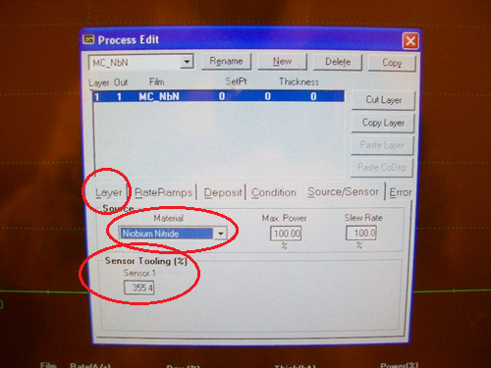
- From the upper left select Edit then Process.
- Click new and name your process the same as your film. Click on the Layer tab and select your film from the list. Double check and make sure that your Material and Sensor Tooling settings are correct. Close the window and click yes.
- Your process and film name should be displayed at the top and bottom left.

E-Beam Evaporation
Don’t touch!
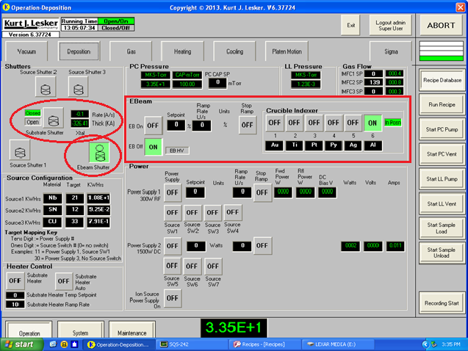
Don’t hit! This’s for ion milling.
0.05
<25
power
Grey when out of position, like when switching.
Error messages may be here.
- On the Deposition page the e-beam controls are near the top. The six materials currently in the system are listed.
- Select the material you want to use.
  - To select the material the e-beam off (EB Off) must be turned on.
- When the light to the right of the materials (In Posn) turns green then the material is in position
- Turn the e-beam off (EB Off), off and the e-beam on (EB On), on.
- The two boxes next to e-beam on are power (Setpoint) and Ramp Rate. Set the ramp rate before setting power. For most materials a ramp rate of 0.05 is preferred. This minimizes shock to the crucible. Now set the power to what you want.
  - If you have never used the material before check the log book to see what power other users have used for that material.
- Open the Ebeam Shutter and note the deposition rate. If it is too low increase the power.
- Go to the SQS-242 software and zero the thickness count.
- On the deposition page, open the Substrate Shutter.
- Close the Substrate Shutter once the desired thickness is reached.
- Return the power to zero and close the Ebeam Shutter.
- Turn the e-beam on, off and the e-beam off, on.
- Make a note in the log book about power and deposition rate and note any problems.
- On the log sheet make a note of what materials and how many nm of each you used.
Notes:
- When there is error message, deal with it slowly. It may disappear by itself.
- Make sure the material is melting.
- We can go down by rate of 0.2 to save material.

DC Sputtering 1 (for metal)

2
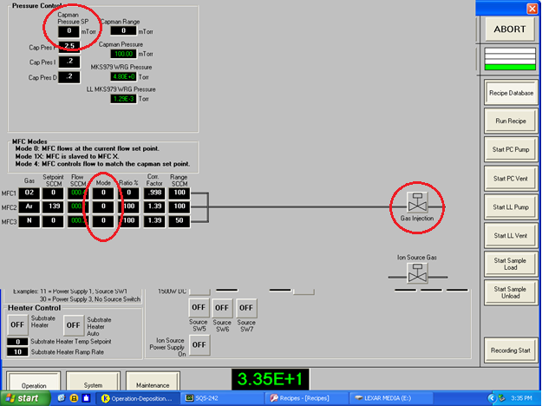

3

1
- Turn on your gas of choice on the panel behind the power rack.
- On the Gas page set the Capman Pressure SP to 30 mtorr.
- Set the Mode for the chosen gas to 4. Press Gas Injection.

DC Sputtering 2
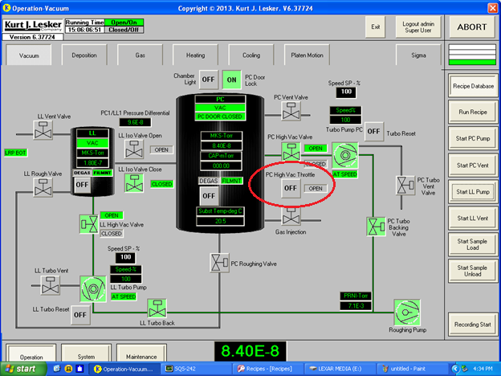
- Go to the Vacuum page. Press PC High Vac Throttle. This will partially close the gate valve.
- Now go to the Deposition page.

DC Sputtering 3
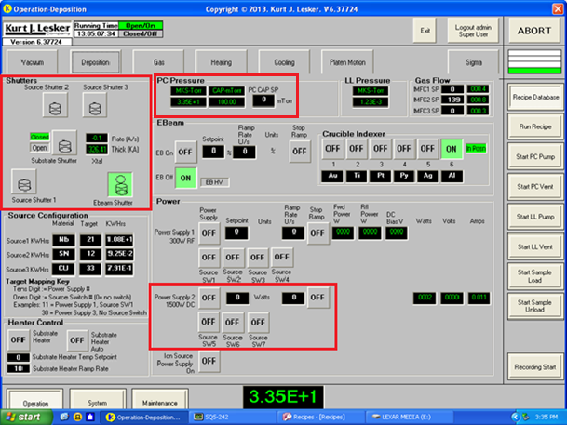

- On the Deposition page the DC sputter controls are located towards the bottom.
- Source SW5, 6, and 7 are guns 1, 2, and 3. The materials loaded in the guns are listed under Source Configuration on the left.
- Turn on the source and then the DC power (Power Supply 2 1500W DC) above them. Input the power you want to the right of the power supply.
  - If you don’t know how much power check the log book to see what power other users have used with the same material.
- Open the appropriate Source Shutter. Adjust power and pressure to achieve the desired rate. Pressure can be adjusted (PC CAP SP) and monitored in the top middle under PC Pressure.
- Go to the SQS-242 software and zero the thickness count.
- On the deposition page, open the Substrate Shutter.
- Close the Substrate Shutter once the desired thickness is reached.
- Return the power to zero and close the Source Shutter.
- Turn the DC power off and then the Source SW off.
- Make a note in the log book about power and deposition rate and note any problems.
- On the log sheet make a note of what materials and how many nm of each you used.
- Reopen the PC High Vac Throttle valve.
- On the Gas page reset the Capman Pressure SP to zero and the Mode to zero.
- Turn off the Gas Injection.
- Turn the gas off at the wall behind the machine.

RF Sputtering 1 (for insulator & metal)

Not reliable when gas flowing

Ion milling
- Turn on your gas of choice on the panel behind the power rack. (Ar is the most used)
- On the Gas page set the Capman Pressure SP to around 30-45 mtorr.
- Set the Mode for the chosen gas to 4. Press Gas Injection.

RF Sputtering 2
Turn off when finished
Fix here
- Go to the Vacuum page. Press PC High Vac Throttle. This will partially close the gate valve.
- Now go to the Deposition page.

RF Sputtering 3
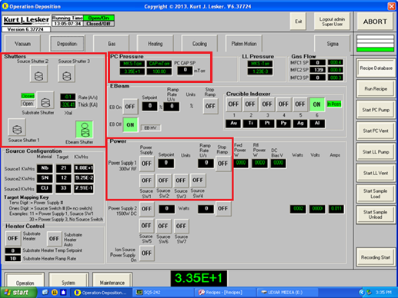

- On the Deposition page the RF sputter controls are between the e-beam and DC sputter controls.
- Source SW1, 2, and 3 are guns 1, 2, and 3. The materials loaded in the guns are listed under Source Configuration on the left.
  - SW4 is to generate a plasma between the sample and the shutter.
- Turn on the source and then the RF power (Power Supply 1 300W RF) above them. Input the power you want to the right of the power supply.
  - If you don’t know how much power check the log book to see what power other users have used with the same material.
- Open the appropriate Source Shutter. Adjust power and pressure to achieve the desired rate. Pressure can be adjusted (PC CAP SP) and monitored in the top middle under PC Pressure.
  - If you can’t get the gun to light, start a DC sputter on an adjacent gun. Then turn it off once the RF gun lights.
- Go to the SQS-242 software and zero the thickness count.
- On the deposition page, open the Substrate Shutter.
- Close the Substrate Shutter once the desired thickness is reached.
- Return the power to zero and close the Source Shutter.
- Turn the RF power off and then the Source SW off.
- Make a note in the log book about power and deposition rate and note any problems.
- On the log sheet make a note of what materials and how many nm of each you used.
- Reopen the PC High Vac Throttle valve.
- On the Gas page reset the Capman Pressure SP to zero and the Mode to zero.
- Turn off the Gas Injection.
- Turn the gas off at the wall behind the machine.

Unload cycle
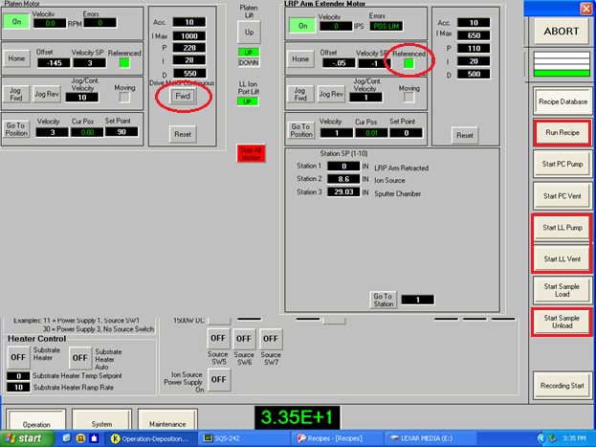
- If your sample is rotating, stop it by pressing the Fwd button.
- Make sure the LRP Arm Referenced light is lit.
  - If not go to the Deposition page and open the Substrate Shutter. Return to the Platen Motion page and jog the arm forward an inch or so, and then press home. The Referenced light should turn on.
- On the Deposition page, make sure all Source Shutters are closed to avoid interference with the sample unload.
- On the Platen Motion page press Start Sample Unload.
- If the unload fails, push Run Recipe and then select motor reset and run. Press Start Sample Unload again.
- Once the unload recipe is complete press Start LL Vent.
- Once the vent recipe is complete open the load lock door and remove your sample and note any problems in the log book.
- Either load a new sample or don’t. Now press Start LL Pump.

Opening Lab-18 Chamber
- Write down the starting pressure in the log book.
- Go to the Vacuum page.
- Turn PC Door Lock off.
- Close PC High Vac Valve.
- Open PC Vent Valve.
- Remove the manual controller above the keyboard.
- Click menu and go to automatic/manual using the left stick, then switch the selection to manual operation using the right stick. Click right on the right stick and enter 2031 to switch to manual mode.
- Wait for the chamber pressure to get to about 7E+2.
- Turn PC Vent Valve off.
- Open the chamber door and before touching anything use the grounding stick to ground the ebeam tray and the two wires and capacitor below the tray.
- You can use the manual controller to change the ebeam pockets now. In the menu under Set Pocket, select the pocket you want and hold right on the right stick until it moves into place.
- IMPORTANT: The materials are NOT correct on the controller. You must reference the material list on the Deposition page on the computer to determine what’s in each crucible.
- Once you are finished changing/refilling materials, make sure the window shutter is closed before closing the door.
  - If the plastic piece on the door’s window is too dirty to see through, you can cut out a new one. Plastic sheets are usually in the drawer of the desk by Lab-18.
- You can also check the life of the crystal monitor. In the SQS-242 software go to
- Turn PC Door Lock on.
- Turn LL High Vac Valve, LL Turbo Pump, and LL Turbo Back off. Ignore the error that pops up.
- Turn PC Turbo Backing Valve off.
- Turn PC Roughing Valve on.
- On the controller change the ebeam controls back to automatic operation. Push menu/quit until you get back to the main screen.
- Wait until the pressure of the chamber reaches 5E-1.
- Close PC Roughing Valve.
- Open PC Turbo Backing Valve.
- Open PC High Vac Valve.
- Click the Start LL Pump recipe.
- On the Deposition page, switch to a different ebeam source. Once it’s in position turn the ebeam power on. If an error pops up hit menu/quit on the controller a few times and it should go away.
- IMPORTANT: If you switched any materials make sure you change the name of the appropriate pocket on the Deposition page. Just click on the name to change it. Also, make sure you update the sheet on the clean room door to reflect your changes.

Things to record in the log book
Date 11.29 | Starting pressure 8.40e-8
 | Material Ti | Setpoint 13% | Rate 0.7A/s
 | … (for any other materials used)
 | Ending pressure 8.40e-8

